CHEM-115 Quiz 4 (Chapter 7) October 13, 2017

Name: ______________________ Section: ______
- Addition of functional groups to hydrocarbons generally _____________ their solubility in water.
a) increases b) decreases c) has no effect on d) could increase or decrease

- Which of the following functional groups does not contain an oxygen atom? Circle all that apply
a) ketone b) amide c) carboxylic acid d) amine e) aldehyde

- Which of the following functional groups makes the strongest intermolecular hydrogen bonds?
a) ester b) ether c) carboxylic acid d) aldehyde e) amine

- Which of the following functional groups has a molecular shape similar to that of water?
a) carboxylic acid b) amine c) ketone d) amine e) alcohol
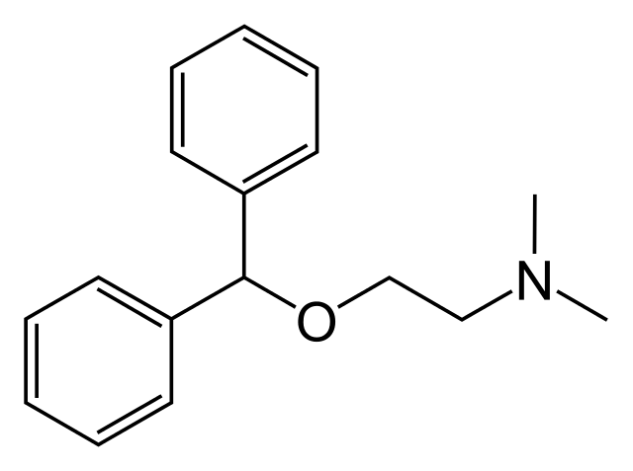
- Circle & identify 3 different functional groups in
Benadryl, the drug shown to the right.

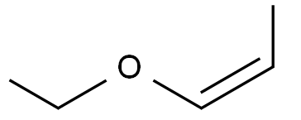
- Provide the proper IUPAC name for the compound shown to the right:

CHEM-115 Quiz 4 (Chapter 7) October 13, 2017

Name: ______________________ Section: ______
- Addition of functional groups to hydrocarbons generally _____________ their solubility in water.
a) increases b) decreases c) has no effect on d) could increase or decrease

- Which of the following functional groups does not contain an oxygen atom? Circle all that apply
a) ketone b) amide c) carboxylic acid d) amine e) aldehyde

- Which of the following functional groups makes the strongest intermolecular hydrogen bonds?
a) ester b) ether c) carboxylic acid d) aldehyde e) amine

- Which of the following functional groups has a molecular shape similar to that of water?
a) carboxylic acid b) amine c) ketone d) amine e) alcohol
- Circle & identify 3 different functional groups in
Benadryl, the drug shown to the right.

- Provide the proper IUPAC name for the compound shown to the right:
CHEM-115 Quiz 4 (Chapter 7) October 13, 2017

Name: ______________________ Section: ______
- Addition of most functional groups to hydrocarbons _________________ their boiling point.
a) decreases b) increases c) has no effect on d) could increase or decrease

- Which of the following functional groups do not contain a nitrogen atom? Circle all that apply
a) thioester b) amide c) carboxylic acid d) amine e) aldehyde

- Which of the following functional groups cannot form hydrogen bonds in the absence of water?
a) amide b) amine c) carboxylic acid d) alcohol e) ether

- The chemistry of sulfur found in a thioester is very similar to that of the ______found in an ester.
a) oxygen b) carbon c) phosphate d) nitrogen e) hydrogen
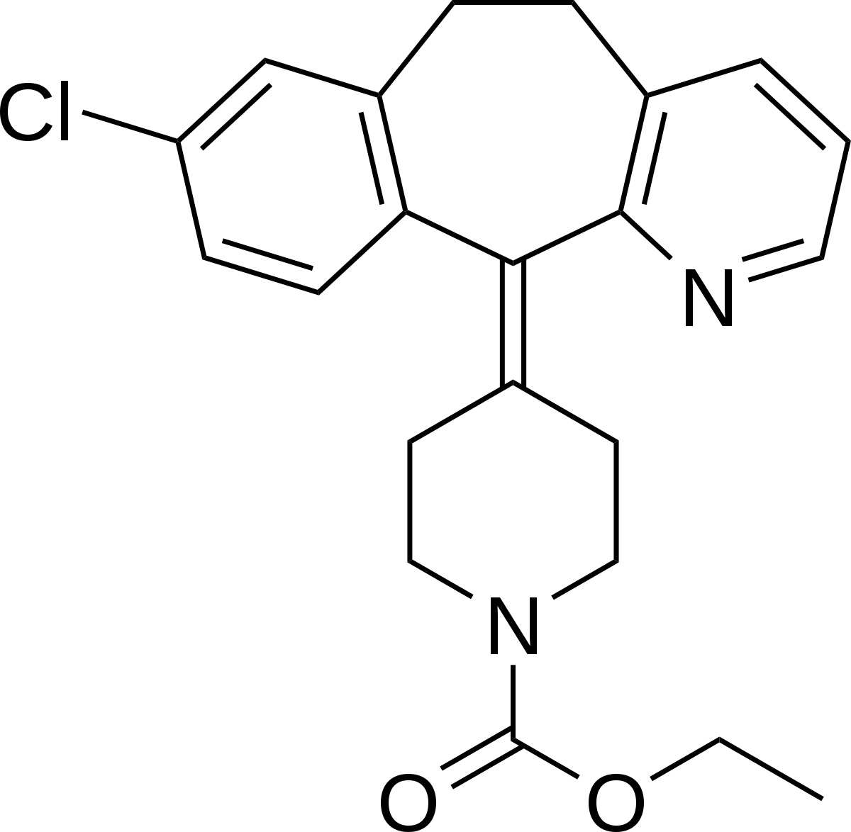
- Circle & identify 3 different functional groups in
Claritin, the drug shown to the right.

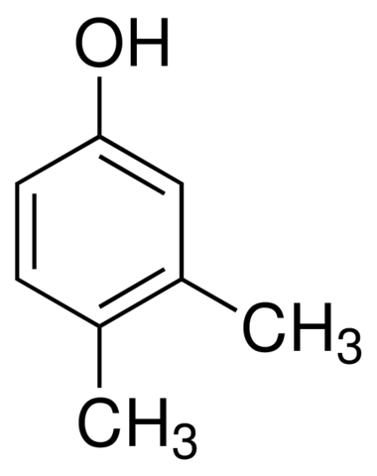

- Provide the proper IUPAC name for the compound shown to the right:

CHEM-115 Quiz 4 (Chapter 7) October 13, 2017

Name: ______________________ Section: ______
- Addition of most functional groups to hydrocarbons _________________ their boiling point.
a) decreases b) increases c) has no effect on d) could increase or decrease

- Which of the following functional groups do not contain a nitrogen atom? Circle all that apply
a) thioester b) amide c) carboxylic acid d) amine e) aldehyde

- Which of the following functional groups cannot form hydrogen bonds in the absence of water?
a) amide b) amine c) carboxylic acid d) alcohol e) ether

- The chemistry of sulfur found in a thioester is very similar to that of the ______found in an ester.
a) oxygen b) carbon c) phosphate d) nitrogen e) hydrogen
- Circle & identify 3 different functional groups in
Claritin, the drug shown to the right.

- Provide the proper IUPAC name for the compound shown to the right:

